Bangladesh Army University of Science and Technology (BAUST), Saidpur
Department of Computer Science and Engineering

Lab Report
Course Code: CSE-1100
Course Title: Introduction to Computer System Sessional
Department: B.Sc. Engg. In CSE
Experiment No: 1
Name of Experiment: Write a C program to check whether a number is even or odd.

Name: Nahid Hasan Arif  Roll: 220201075  Date of Experiment: 18.09.2022  Date of Submission: | Name of Teacher:  Designation:  Signature: ………………………………

Name of Experiment: Write a C program to check whether a number is even or odd.
Theory: A C program to check whether a number is even or odd. The number must be an integer.
Code:

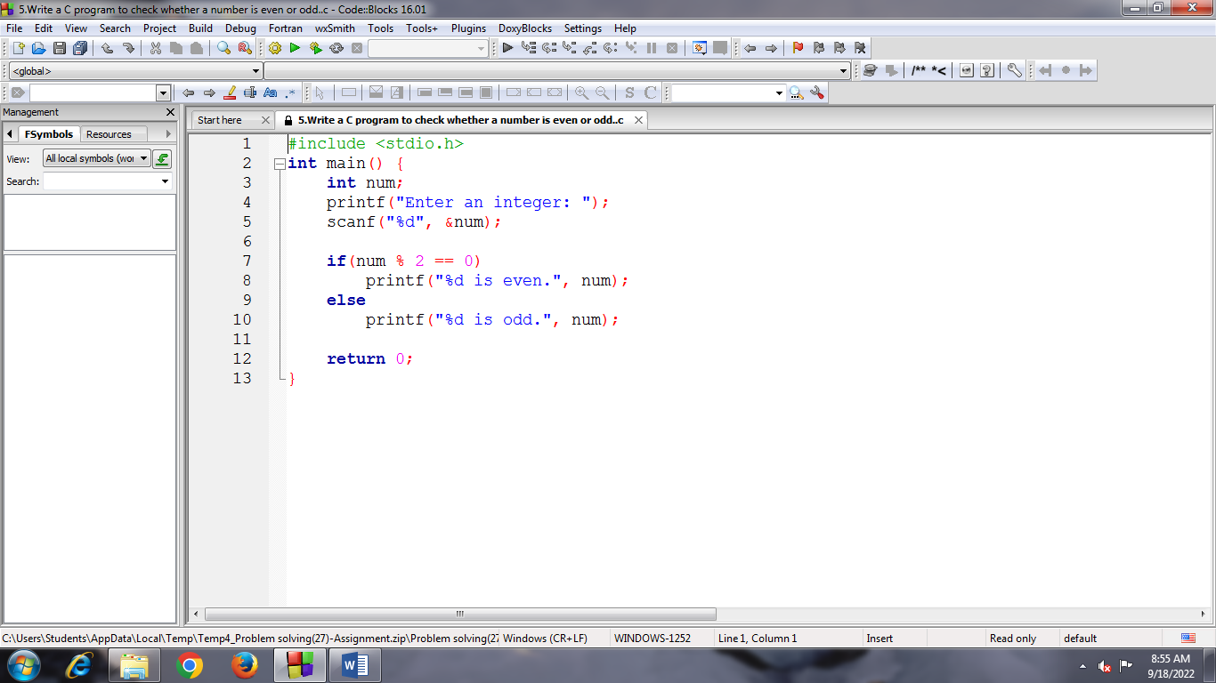
Input:
Enter an integer: 56
Output:
56 is even.
Process returned 0 (0x0) execution time : 1.744 s
Press any key to continue.

